Project Development Phase
Model Performance Test

Date | 10 February 2025
Team ID | LTVIP2025TMID32756
Project Name | POLLEN’S Profiling:Automated Classification Of Pollen Grains
Maximum Marks | 10 Marks

Model Performance Testing:
Project team shall fill the following information in model performance testing template.
S.No. | Parameter | Values | Screenshot
 | Metrics | Regression Model:  MAE - , MSE - , RMSE - , R2 score -  Classification Model:  Confusion Matrix - , Accuray Score- & Classification Report - | 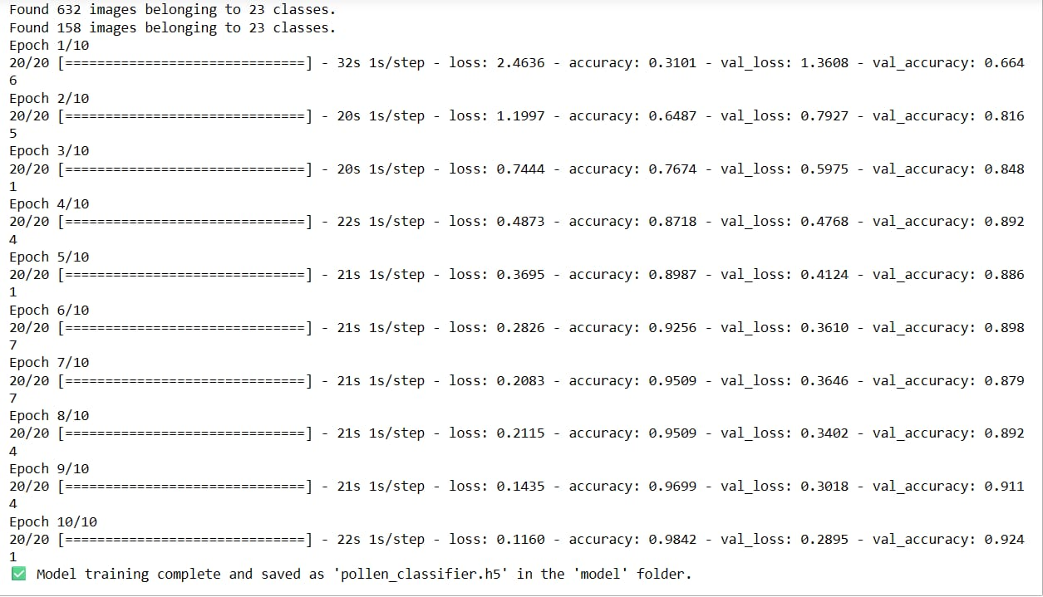
 | Tune the Model | Hyperparameter Tuning -  Validation Method - | 